Beneficiary’s file

NAME: EGROS Office Continental

ACTIVITY PROFILE: Software Development

NUMBER OF EMPLOYEES: 700+

THE ORGANIZATIONAL STRUCTURE: 1department/floor

BUILDING BLUEPRINTS:

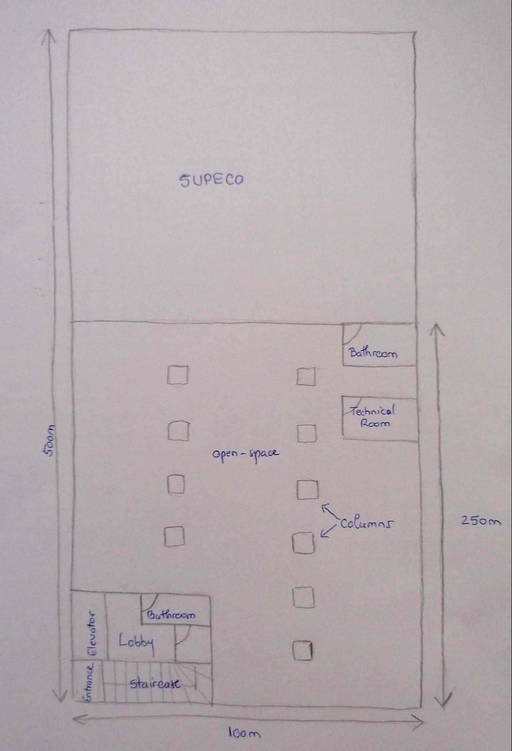

* The ground floor is taken by the SUPECO store
* The offices occupy all 6 floors of the building
* The total area of the offices is 9.500 m²

DEVELOPMENT PLAN

NUMBER OF EMPLOYEES AFTER 5 YEARS: 1500+

AVAILABLE JOBS:

* software developers
* testers
* Integrators
* managers
* building mentenance stuff

SPECIAL CONDITIONS:

* servers
* secured network
* security cameras on the staircase, elevator and open-space